1) By Default, when we are creating Linux server GIT is pre-installed.

* root@ip-172-31-30-74:~# git --version
* git version 2.34.1

2) GIT was existing prior to Devops

* When GIT Started > 2005
* When Devops Started > 2007-2008

3) What is Versioning?

* git version 2.34.1 <Major release><minor release><fix pack>
* 2.30.1
* 2.31.1
* 2.32.1
* 2.33.1
* 2.34.1

4) In confluence we maintain multiple versions internally, but file name would be same

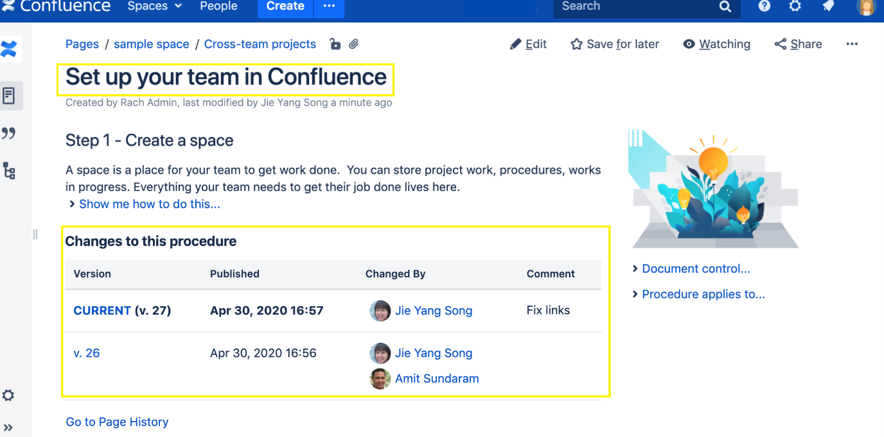

Commit1> This is my first file

Commit2> This is my second commit

Commit3> This is my third commit

5) GIT is a tool that allow versioning but how we can come to know where to apply versioning.

Patrick_umesh_git_demo folder created for demo purpose

6) How to check versioning is enable or not?

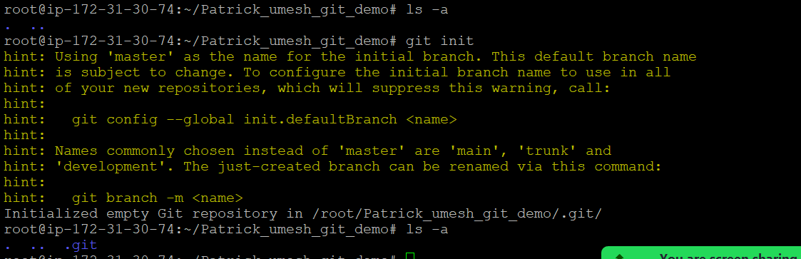

7) We need to setup our identity

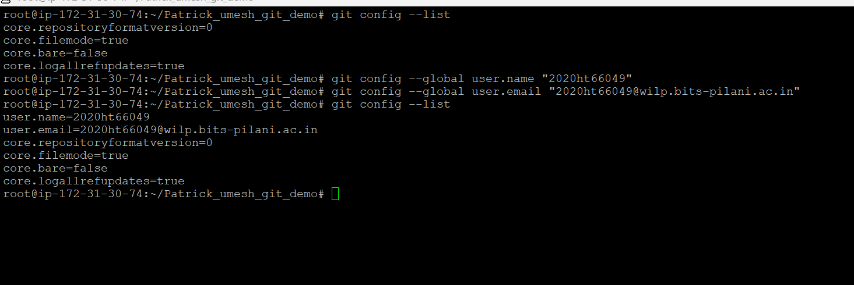

8) How to create repository > repository is a place where we store information.

Link> <https://docs.github.com/en/get-started/quickstart/create-a-repo>

9) We would be getting below command when we would be creating repository

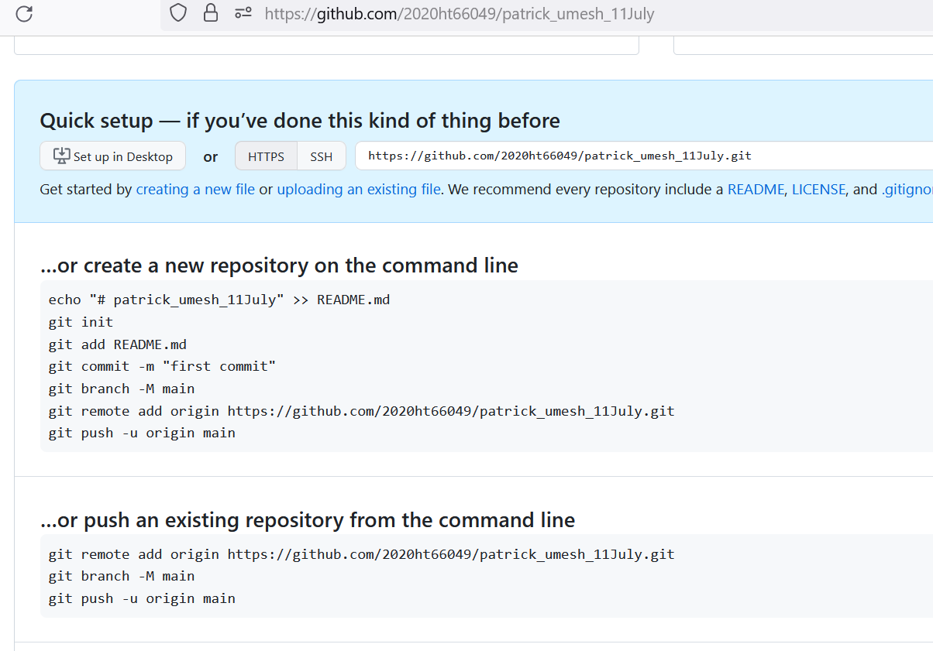

Area of GIT: GIT has 4 area

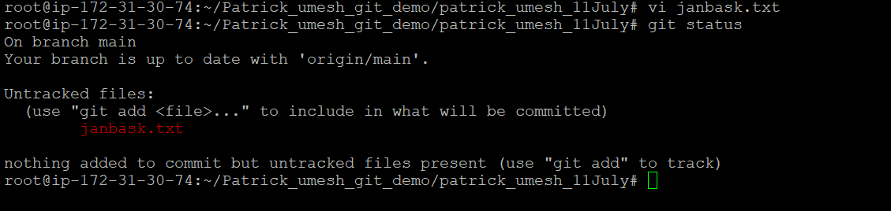

Case study: Suppose you have 100MB image, and you want to minimize the size?

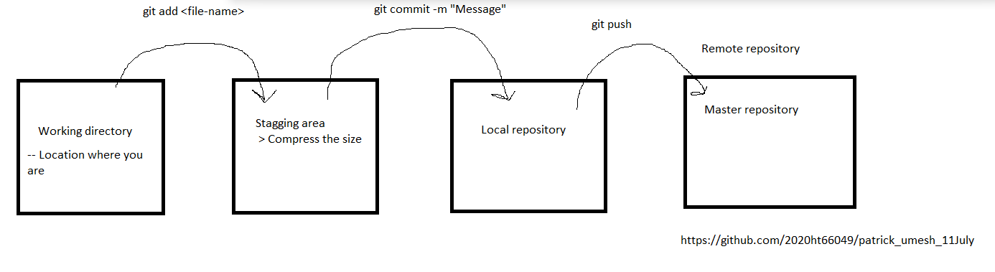

*** GIT is not supporting user authentication, so you need to generate the token. After generating token, you would be running below command

git remote set-url origin [https://<GITHUB_ACCESS_TOKEN>@github.com/<GITHUB_USERNAME>/<REPOSITORY_NAME>.git](https://%3cGITHUB_ACCESS_TOKEN%3e@github.com/%3cGITHUB_USERNAME%3e/%3cREPOSITORY_NAME%3e.git)

